**PRACTICAL NO 0**

**AIM :** Starting Raspbian OS, Familiarising with Raspberry Pi Components and interface, Connecting to ethernet, Monitor, USB.

**HARDWARE REQUIREMENT:-**

Arduino basic kit or Raspberry Pi starter kit

**SOFTWARE REQUIREMENT:-**

Can be installed on LINUX and a stripped down IOT version of Windows 10.

**INTRODUCTION TO (IOT):-**

The Internet of Things (IOT) is the interconnection of uniquely identifiable embedded computing devices within the existing Internet infrastructure. The Internet of Things connects devices and vehicles using electronic sensors and the Internet.

**DESCRIPTION:-**

**Embedded platform**:-

**1) Arduino:**

It is probably the best starting point for embedded based IoT. Based Arduino Boards don’t come with Ethernet shield or Wi-Fi shield and for Arduino to be able to work as IoT device, their need to select Arduino with Ethernet shield or Wi-Fi shield. Arduino run on the other hand is a board that comes ported with Ethernet shield.

**2) Raspberry Pi:**

It is probably one of the best things to happen in DIY (DO it Yourself) IoT. A wide  
range of data driven applications like Home Automation Server to Home Multimedia server, File Server can be developed with Pi. Pi like Arduino has general purpose IO pins. But seamless working with sensors is bit tedious in Pi. Another efficient IoT Board is Intel Edition which has integrated BLE, Wi-Fi among host of other features. It supports wide range of industry standard hardware (over 30) through 70 pin interface.

**3) Intel Galileo:**

It is another good offering by Intel which supports the same shielding that of Arduino Uno. So it can be said to be first Intel powered device which is Arduino compatible. It has among other thing a USB host controller like Raspberry Pi which makes this an attractive hardware. Galileo also has Ethernet shield built-in.

**RASPBERRY PI MODEL B HARDWARE DIAGRAM:-**

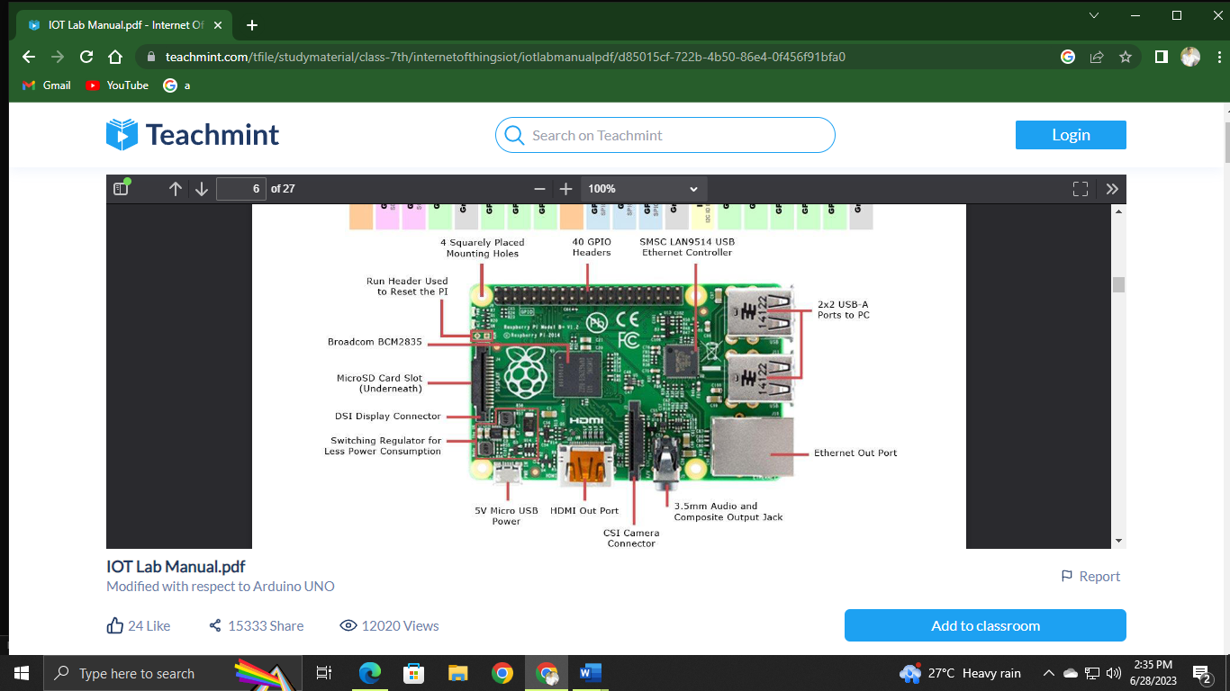

**GPIO PINOUT DIAGRAM:-**

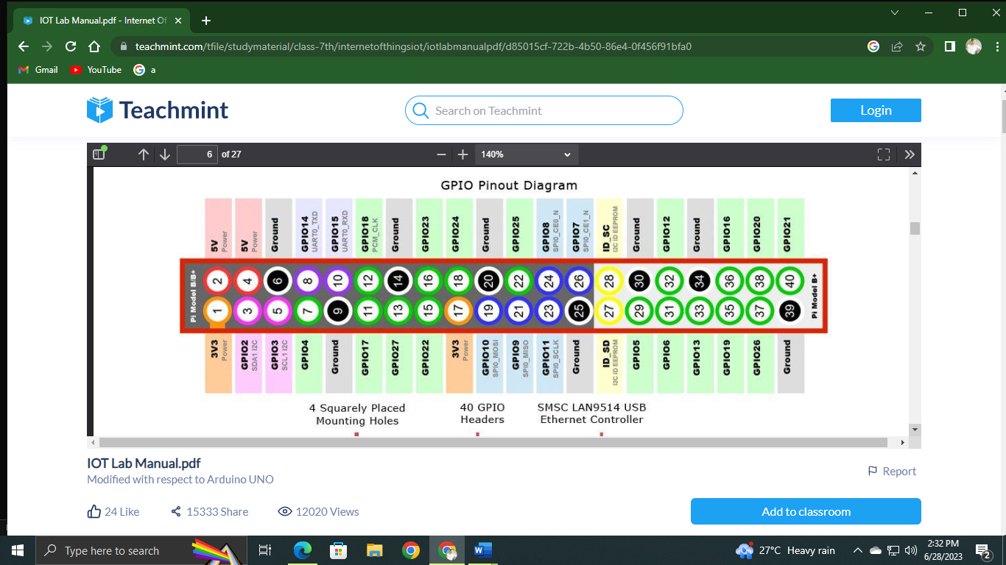

**Description of Raspberry Pi 3 Model B-**

**1. CPU:**

Raspberry Pi 3 uses Broadcom BCM2837 SOC 64-bit quad-core ARM Cortex A53  
(ARMv8) with 512KB shared L2 cache.

**2. Memory:**

Provided with 1GB of RAM

**3. Wi-Fi:**

Support 802.11n WirelessLAN

**4. Bluetooth:**

Supports Bluetooth 4.1 (BLE)

**5. USB Ports:**

USB ports which allow attaching four different USB devices like keyboard,  
mouse etc

**6. Ethernet Port:**

Standard Ethernet port to quickly setup and access internet. This can be very  
useful when we want to setup raspberry pi for the first time without a monitor.

**7. GPIO pins**:

Raspberry Pi 3 supports 40 GPIO pins General Purpose Input Output. These  
digital input/ output pins can be used to drive LED, Switches and Sensors etc.

**8. Full HDMI Port**:

Support HDMI port (High-Definition Multimedia Interface) which can be  
used to quickly connect raspberry pi to HDMI Monitor. With HDMI Cable and Monitor we  
can add Screen to Raspberry Pi.

**9. Micro SD card slot**:

The micro SD card will hold the operating system which will boot  
while we power on Raspberry Pi 3.

**10. Audio/Video:**

Combined 3.5mm audio jack and composite video.

**11. Display interface (DSI):**

Enable us to interface Display Module

**12. Camera interface (CSI):**

Enable us to interface Camera Module.

**13. Graphics Support:**

VideoCore IV 3D graphics core for advance graphics capabilities